Mini Project Report On
“AgriManage – Farm Management System”

Submitted by:
Atharva Gogawale (RBT25CB053)
Gauree Rajapure (RBT25CB052)

Under the guidance of
Prof. Rutuja S. Bachhav
Course: DBMS

Academic Year: 2026–27 (Semester III)

Table of Contents

1. Abstract 5
2. Introduction 6
3. Literature Survey / Existing System 7
4. Proposed System 8
5. Methodology / Implementation 10
6. Results and Discussion 13
7. Conclusion and Future Scope 15
8. References 16
9. Appendix (Optional) 17

- Course Outcomes:
CO1: Design a database schema and 2 –tier application for a given problem statement.
CO2: Design SQL DDL/DML quries to create, secure, populate, maintain, and query a database using integrity constraint, stored function/procedure, cursor, trigger using PL/SQL block.
CO2: Design NO SQL query using mongoDB platform.

- PO Mapped
PO1: Engineering Knowledge: Apply knowledge of mathematics, natural science, computing,
engineering fundamentals and an engineering specialization as specified in WK1 to WK4 respectively to develop to the solution of complex engineering problems
PO2: Problem Analysis: Identify, formulate, review research literature and analyze complex engineering problems reaching substantiated conclusions with consideration for sustainable development.
PO3: Design/Development of Solutions: Design creative solutions for complex engineering problems and design/develop systems/components/processes to meet identified needs with consideration for the public health and safety, whole-life cost, net zero carbon, culture, society and environment as required.
PO4: Conduct Investigations of Complex Problems: Conduct investigations of complex engineering problems using research-based knowledge including design of experiments, modeling, analysis & interpretation of data to provide valid conclusions.
PO5: Engineering Tool Usage: Create, select and apply appropriate techniques, resources and modern engineering &amp; IT tools, including prediction and modeling recognizing their limitations to solve complex engineering problems.
PO8: Individual and Collaborative Team work: Function effectively as an individual, and as a member or leader in diverse/multi-disciplinary teams.
PO9: Communication: Communicate effectively and inclusively within the engineering community and society at large, such as being able to comprehend and write effective reports and design documentation, make effective presentations considering cultural, language, and learning differences
PO10: Project Management and Finance: Apply knowledge and understanding of engineering management principles and economic decision-making and apply these to one’s own work, as a member and leader in a team, and to manage projects and in multidisciplinary environments.
PO11: Life-Long Learning: Recognize the need for, and have the preparation and ability for i) independent and life-long learning ii) adaptability to new and emerging technologies and iii) critical thinking in the broadest context of technological change.

- PSO Mapped
PSO 1: Integrated Technical Proficiency: Ability to analyze, designs, and implement comprehensive software and business systems using modern tools and techniques, ensuring intelligent, efficient, and sustainable solutions.
PSO 2: Data-Driven Decision Making: Ability to apply mathematical and data analytics methods including algorithms, statisticalmodels, and data structures to solve complex computational and business problems and support innovation.
PSO 3: Interdisciplinary Collaboration &amp; Professionalism: Ability to effectively collaborate in multidisciplinary teams, integrating technical and business perspectives, and to communicate and manage projects with professional ethics and societal responsibility.
- SDG Goals Mapped
SDG 4: Quality Education: Develops students’ practical skills in database design, SQL, PL/SQL, NoSQL, and modern database technologies.
SDG 8: Decent Work and Economic Growth: Enhances students’ technical and problem-solving skills required for employment and professional development in the IT industry.
SDG 9: Industry, Innovation and Infrastructure: Promotes the development of technology-based database solutions using SQL, PL/SQL, and MongoDB.
SDG 12: Responsible Consumption and Production: Encourages efficient data management, storage, and utilization of computing resources.

- Abstract
AgriManage is a web-based farm management system developed as a DBMS mini project to replace manual, scattered farm records with a single integrated database. The system manages thirteen related entities – farmers, farmer profiles, lands, soil tests, seasons, crops, cultivations, inputs, crop inputs, buyers, sales, farm activities and equipment – and presents them through a dashboard and a generic page for each entity. A two-tier architecture is used: a plain HTML, CSS and JavaScript client served from the /public folder, and a Node.js with Express REST API that stores data in MongoDB through Mongoose. Relationships between entities are maintained through references, and the sales module automatically calculates the total amount as quantity multiplied by price per unit. The dashboard displays the number of records in every module and the total sales revenue, which is ₹3,84,000 for the sample data. The project demonstrates schema design, CRUD operations, referential relationships and NoSQL data handling, and provides a low-cost foundation that can be extended with authentication, charts and detailed reporting for real-world farms.

- Introduction
  - Background / Motivation
Agriculture is the main source of livelihood for a large part of rural India, yet most farmers still record land details, crop cycles, input purchases and sales in notebooks or isolated spreadsheets. Such records are difficult to search, easy to lose and cannot show how one piece of data relates to another. A database-driven system stores the data once, links it through relationships and makes it available instantly. This need motivated the development of AgriManage as a practical application of DBMS concepts.
  - Problem Definition
Farm data is maintained manually, which leads to duplication, inconsistency and no connection between land, cultivation, inputs and sales. A farmer cannot quickly find which crop was grown on which land in which season, what inputs were used, or how much revenue was earned. The problem is to design and implement a database and a simple web application that stores all such data in a structured, related form.
  - Objectives
- To design a database schema of 13 related farm entities with suitable relationships.
- To develop a two-tier application with a browser client and an Express + MongoDB backend.
- To provide create, read, update and delete (CRUD) operations for every entity.
- To maintain data integrity using references between collections and automatic calculation of sales totals.
- To present a dashboard with record counts and total sales revenue for quick decision making.

- Literature Survey / Existing System
  - Review of related tools or existing systems
Several approaches are commonly used for managing farm information. Their strengths and limitations are summarised below.
System | Strengths | Limitations
Manual registers | No cost, familiar to farmers | Easily lost, no search, no relationships, errors
Spreadsheets (Excel) | Easy tables and formulas | Redundant data, weak links between sheets, no multi-user access
Government portals / apps (e-NAM, Kisan Suvidha) | Market prices, weather and advisory | Not designed to store a farmer’s own land-to-sale records
Generic ERP / farm software | Feature rich | Costly and complex for small farms

  - Gaps identified
The existing approaches either keep data in unrelated files or focus on market information rather than farm records. There is a gap for a simple, low-cost and integrated system that links the farmer, land, soil test, season, crop, inputs, equipment and sales in one database. AgriManage is developed to fill this gap.

- Proposed System
  - System Overview
AgriManage is a browser-based application. The user opens the dashboard at http://localhost:3000, selects a module from the top menu and manages its records. The Express server exposes a REST API, validates and cleans the incoming data and stores it in MongoDB collections defined with Mongoose. Sample data is loaded using the seed.js script.
  - Features / Scope
- Thirteen modules: Farmers, Farmer Profiles, Lands, Soil Tests, Seasons, Crops, Cultivations, Inputs, Crop Inputs, Buyers, Sales, Farm Activities and Equipment, plus a Reports page.
- Dashboard with record count of every module and total sales revenue.
- Add, view, edit and delete records for every module through a common entity page.
- Reference fields connect related collections (for example, a cultivation refers to land and crop).
- Automatic sales total: total_amount = quantity × price_per_unit.
- Scope: single-user, local deployment suitable for small farms and academic demonstration.
The system follows a three-part (client, server, database) structure as shown in Fig. 1. The entity relationship diagram of the database is shown in Fig. 2 (relationships are shown parent to child).
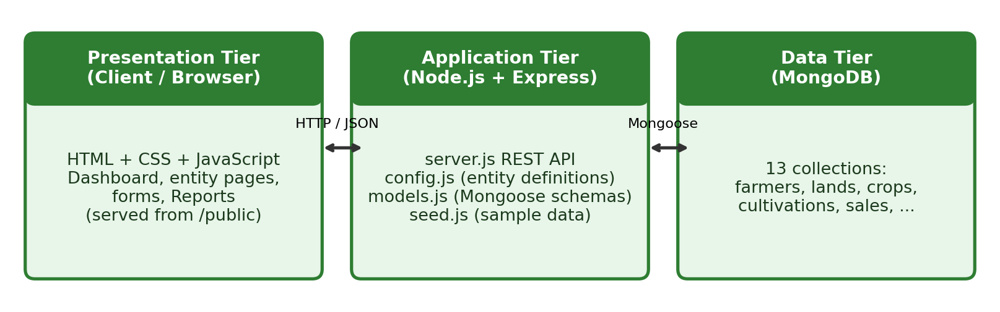
Fig. 1: System architecture of AgriManage
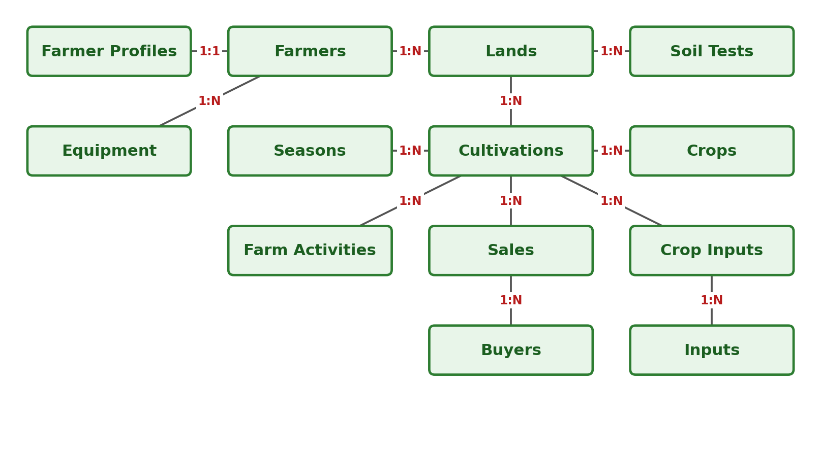
Fig. 2: Entity relationship diagram
  - System Architecture Diagram

- Methodology / Implementation
  - Tools and Technologies Used
Component | Technology | Purpose
Backend runtime | Node.js | Runs server.js
Web framework | Express.js | REST API, JSON parsing, static file serving
Database | MongoDB | NoSQL document storage
ODM | Mongoose | Schemas and references (models.js)
Frontend | HTML, CSS, JavaScript | Dashboard and entity pages in /public
Tools | VS Code, npm, web browser | Development, packages and testing

  - Modules Description
Module | Description
Farmers | Basic details of each farmer
Farmer Profiles | Extended profile of a farmer (one-to-one)
Lands | Land parcels owned or used by a farmer
Soil Tests | Soil test records of a land
Seasons | Crop seasons (e.g. Kharif, Rabi)
Crops | Crops that can be cultivated
Cultivations | Crop grown on a land in a season
Inputs | Seeds, fertilizers, pesticides and similar items
Crop Inputs | Inputs used for a cultivation (link table)
Buyers | Buyers of farm produce
Sales | Sale of produce to a buyer with automatic total
Farm Activities | Activities carried out during cultivation
Equipment | Farm equipment details
Reports | Summary view of stored data

  - Algorithms / Frameworks (if applicable)
AgriManage uses a configuration-driven design. The file config.js lists every entity with its fields and field types (such as ref and auto), and models.js builds the Mongoose models from it. server.js therefore serves all entities with the same generic REST handlers, and the frontend entity page (entity.html?e=<entity>) renders its form and table from the same definition. Three helper functions support this: wrap sends any error as a JSON response with status 400, refs finds the reference fields of an entity, and clean removes auto-generated and empty fields from the request body. For the sales entity, the server computes total_amount = quantity × price_per_unit before saving.
  - Screenshots or Outputs
The dashboard (Fig. 3) shows the record count of each module and the total sales revenue. Fig. 4 shows the backend code, and the terminal output confirms that the server starts with the command node server.js and is available at http://localhost:3000.
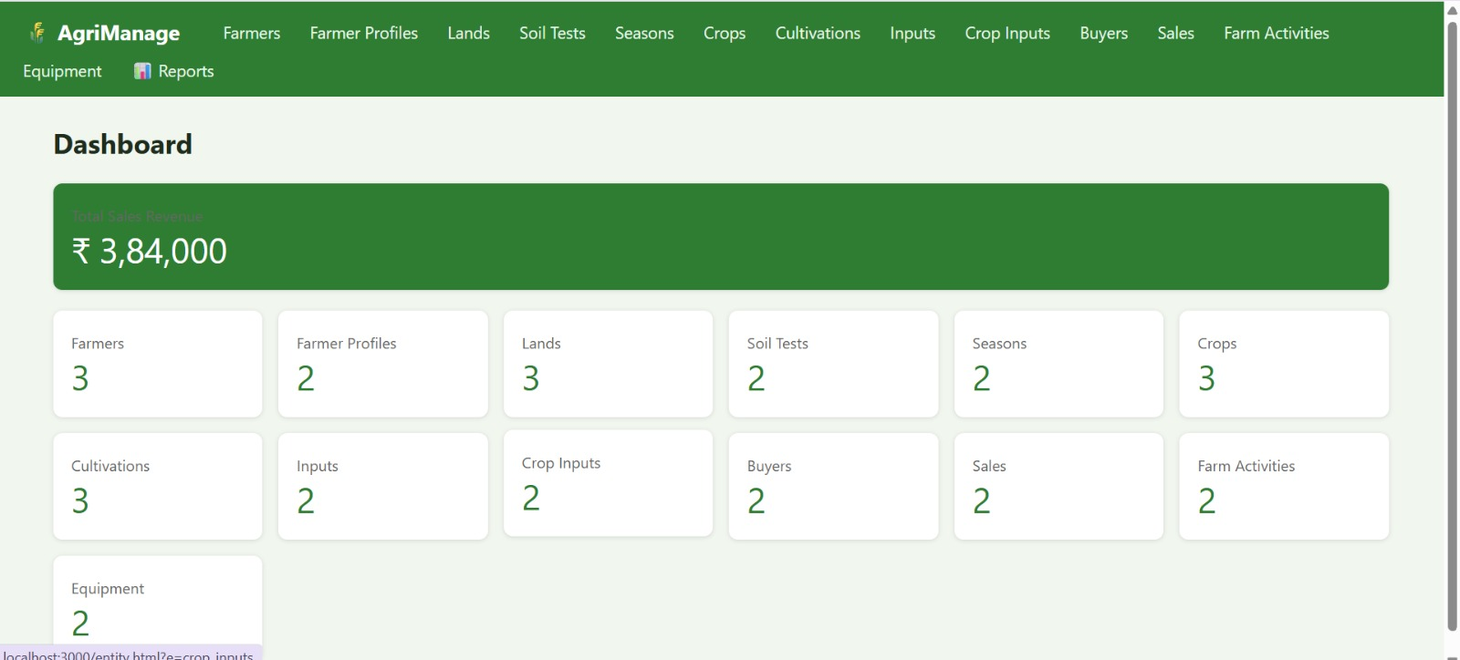
Fig. 3: AgriManage dashboard
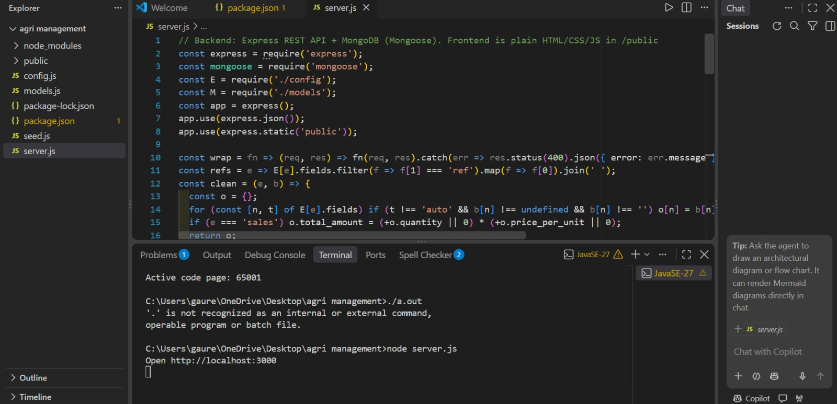
Fig. 4: Backend code (server.js) and server start in terminal

- Results and Discussion
  - Outputs achieved
All thirteen modules were implemented and tested with sample data loaded through seed.js. The dashboard reports the following record counts and a total sales revenue of ₹3,84,000.
Module | Records
Farmers | 3
Farmer Profiles | 2
Lands | 3
Soil Tests | 2
Seasons | 2
Crops | 3
Cultivations | 3
Inputs | 2
Crop Inputs | 2
Buyers | 2
Sales | 2
Farm Activities | 2
Equipment | 2

  - Performance / Accuracy (if measurable)
No formal benchmark was carried out. With the sample data on a local machine, pages load and records are saved without noticeable delay. The sales total is calculated by the server for every record, so the revenue shown on the dashboard is consistent with the stored data.
  - Comparison with existing methods
AgriManage is compared with the common alternatives below.
Feature | Manual records | Spreadsheet | AgriManage
Linked data (land–crop–sale) | No | Limited | Yes (references)
Search and update | Slow | Moderate | Fast, per module
Automatic totals | No | Formulas | Yes (sales total)
Dashboard summary | No | Manual | Yes
Cost | Free | Low | Free (open source)

- Conclusion and Future Scope
  - Summary of achievements
The AgriManage project successfully designs and implements a database-driven farm management system. It covers schema design for 13 related entities, a two-tier web application, full CRUD operations, references between collections, automatic sales calculation and a dashboard. The project gave practical experience in NoSQL design with MongoDB, REST API development and building a complete database application.
  - Limitations and potential improvements
- Limitations: no user login or roles, basic validation only, no charts, and no export of reports.
- Future improvements: user authentication, charts and graphs, PDF/Excel report export, weather and market-price integration, a mobile application and cloud deployment.

- References
[1] A. Silberschatz, H. F. Korth and S. Sudarshan, Database System Concepts, McGraw-Hill.
[2] R. Elmasri and S. B. Navathe, Fundamentals of Database Systems, Pearson.
[3] MongoDB Documentation, https://www.mongodb.com/docs/
[4] Express.js Documentation, https://expressjs.com/
[5] Mongoose Documentation, https://mongoosejs.com/docs/
[6] Node.js Documentation, https://nodejs.org/en/docs/
[7] MDN Web Docs (HTML, CSS, JavaScript), https://developer.mozilla.org/

- Appendix (Optional)
  - Source code snippets
server.js (excerpt, first 16 lines)
// Backend: Express REST API + MongoDB (Mongoose). Frontend is plain HTML/CSS/JS in /public
const express = require('express');
const mongoose = require('mongoose');
const E = require('./config');
const M = require('./models');
const app = express();
app.use(express.json());
app.use(express.static('public'));

const wrap = fn => (req, res) => fn(req, res).catch(err => res.status(400).json({ error: err.message }));
const refs = e => E[e].fields.filter(f => f[1] === 'ref').map(f => f[0]).join(' ');
const clean = (e, b) => {
const o = {};
for (const [n, t] of E[e].fields) if (t !== 'auto' && b[n] !== undefined && b[n] !== '') o[n] = b[n];
if (e === 'sales') o.total_amount = (+o.quantity || 0) * (+o.price_per_unit || 0);
return o;
  - Additional screenshots
Run the project: install packages with npm install, load sample data with node seed.js, start the server with node server.js and open http://localhost:3000. Fig. 3 and Fig. 4 in Section 5 show the dashboard and backend code screenshots.

